3. ITERATIVE DEEPNING SEARCH

def depth_limited_search(node, goal, graph, limit, path):
if node == goal:
return path + [node]

if limit == 0:
return None

for child in graph.get(node, []):
if child not in path:
result = depth_limited_search(
child, goal, graph, limit - 1, path + [node]
)
if result is not None:
return result

return None

def iterative_deepening_search(initial, goal, graph, maximum_depth):
for depth in range(maximum_depth + 1):
result = depth_limited_search(
initial, goal, graph, depth, []
)

if result is not None:
print("Goal found!")
print("Solution Path:", " -> ".join(result))
print("Depth:", len(result) - 1)
return

print("Goal not found within the specified maximum depth.")

# Input
initial = input("Enter initial state: ").strip()
goal = input("Enter goal state: ").strip()
maximum_depth = int(input("Enter maximum depth: "))

n = int(input("Enter number of nodes: "))
graph = {}

print("Enter each node and its children (space-separated, or - if none):")
for _ in range(n):
data = input().strip().split()
node = data[0]
children = [] if len(data) == 1 or data[1] == "-" else data[1:]
graph[node] = children

# Perform Iterative Deepening Search
iterative_deepening_search(initial, goal, graph, maximum_depth)

Output:
Test case 1 : Goal at depth 1
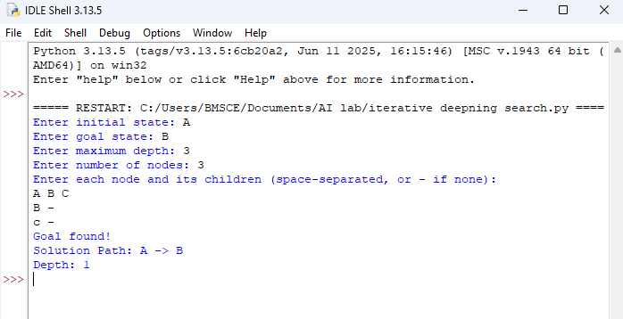
Test case 2 : Goal at depth 2
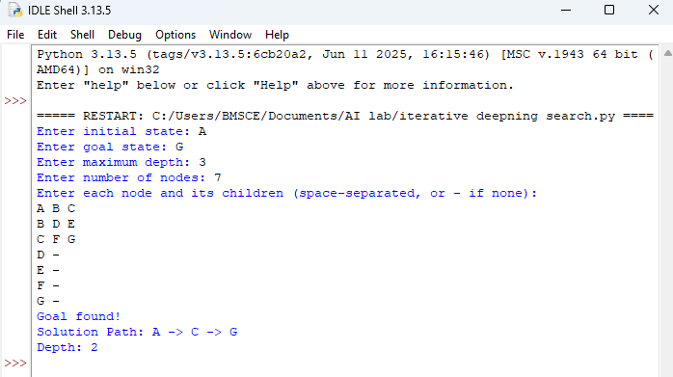

Test case 3 : Goal not present in the search tree
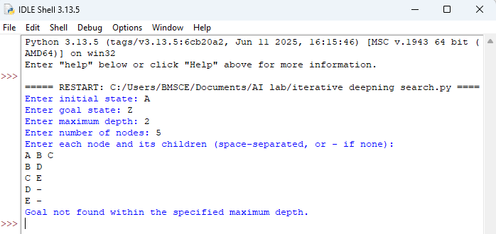

Test case 4 : Goal at maximum depth
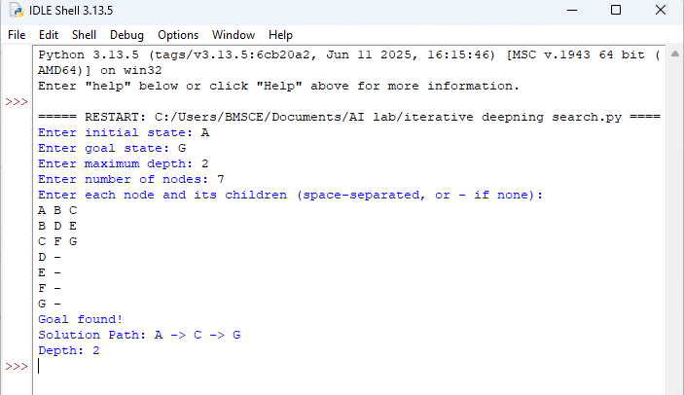
Test case 5: Goal not present in the search tree
